**FIRE120**

**ASN6 Data Fundamentals II Prep**

**Introduction**

The purpose of ASN6 is to prepare you to work with the GSS data and conduct statistical analyses with these data in Microsoft Excel. There are four parts to this assignment:

**Part I**

Read: Statistical Analysis with Excel for Dummies (access for free through the UMD Library) **Chapters 4 and 5**.

**Part II**

1. Finish encoding the data (i.e., creating the –INT variables) for the Political Project (what we did in class in Week 5). (**1 point)**

* Remember that all “no answer” options (i.e., “not applicable,” “no answer,” “don’t know,” “can’t choose”) should be encoded with a period (.) to denote that the integer cell is missing.

1. Using the procedures you learned in Week 5, encode the data (i.e., create –INT variables) for the Technology Project. **(1 point)**

* Remember that all “no answer” options (i.e., “not applicable,” “no answer,” “don’t know,” “can’t choose”) should be encoded with a period (.) to denote that the integer cell is missing.

**Part III**

If you don’t have it already, load the “Data Analysis Toolpak” into your version of Excel.

For Microsoft Windows:

1. Click the **Add-Ins** category under **File -> Options**.
2. In the **Manage** box, click **Excel Add-ins** and then click **Go**.
3. In the **Add-ins available** box, select the **Analysis ToolPak** check box and then click **OK**.

NOTE. If **Analysis ToolPak** is not listed in the **Add-ins available** box, click **Browse** to locate it. If you are prompted that the Analysis ToolPak is not currently installed on your computer, click **Yes** to install it.

For Mac:

1. Click the **Tools** menu, then click **Add-Ins**.
2. In the **Add-ins available** box, select the **Analysis ToolPak** check box and then click **OK**.

NOTE. If **Analysis ToolPak** is not listed in the **Add-ins available** box, click **Browse** to locate it.

**Part IV**

All statistical analyses will be conducted in Excel with the two GSS datasets you created for ASN5: the Political Project and the Technology Project.

1. For the **Technology Project**, provide the mean, median, mode, sample standard deviation, and sample variance for the variables indicated in the table below. **(15 points)**
   * Make sure you use the –INT variables.
   * Round all statistics to two decimal places.

|  |  |  |  |
| --- | --- | --- | --- |
|  | **Hours per day watching TV-INT** | **Email hours per week-INT** | **Www hours per week-INT** |
| **Mean** | 2.9803 | 6.26920 | 11.61829 |
| **Median** | 2 | 2 | 6 |
| **Mode** | 2 | 0 | 2 |
| **Sample Standard Deviation** | 2.58749 | 11.33543 | 15.02230 |
| **Sample Variance** | 6.69512 | 128.49210 | 225.66965 |

1. For the **Political Project**, create a total mean score for “Democracy.”
   * Create a new column in your Excel spreadsheet labeled “Democracy.”
   * This column should contain the scores from the following four variables averaged together (see Ch. 4 for tips):
     + - “How important: citizens have adequate standard of living-INT”
       - “How important: govt protect right of minorities-INT”
       - “How important: ppl given chance to participate in decsns-INT”
       - “How important: citizen engage in acts of civil disobeyed-INT”

* To calculate this subscale, you will use the following formula: =IF(ISERROR(AVERAGE(number1, number2, …)),””,AVERAGE(number1, number2, …)). This tells Excel to take the average of the four variables, and to return a blank cell when the data are missing (i.e., when a period appears in the cell). Below is a screen shot of this formula for the “Democracy” variable.

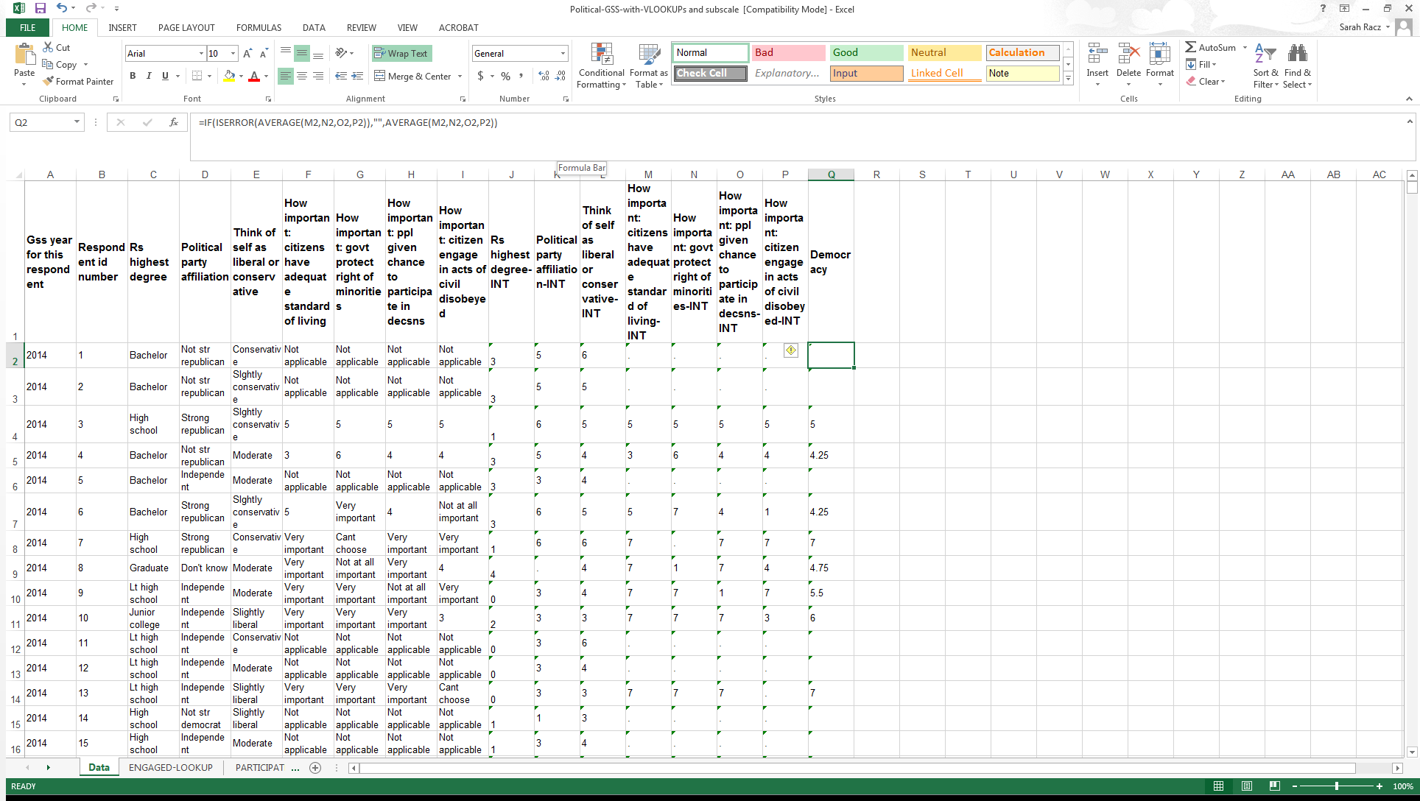

1. For the **Technology Project,** create a total mean score for “Computer Time.”
   * Create a new column in your Excel spreadsheet labeled “Comp Time.”
   * This column should contain the scores from the following two variables averaged together (see screen shot below):
     + - “Email hours per week-INT”
       - “Www hours per week-INT”

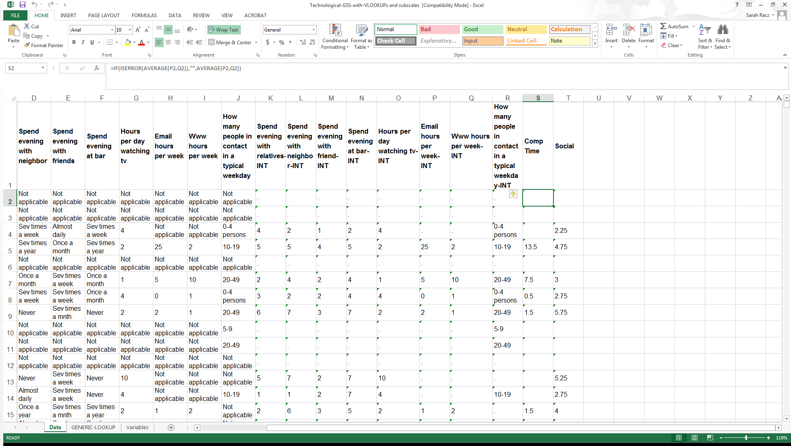

1. Now, create a total mean score for “sociability” for the **Technology Project.**
   * Create a new column in your Excel spreadsheet labeled “Social.”
   * This column should contain the scores from the following four variables averaged together (see screen shot below):
     + - “Spend evening with relatives-INT”
       - “Spend evening with neighbor-INT”
       - “Spend evening with friends-INT”
       - “Spend evening at bar-INT”

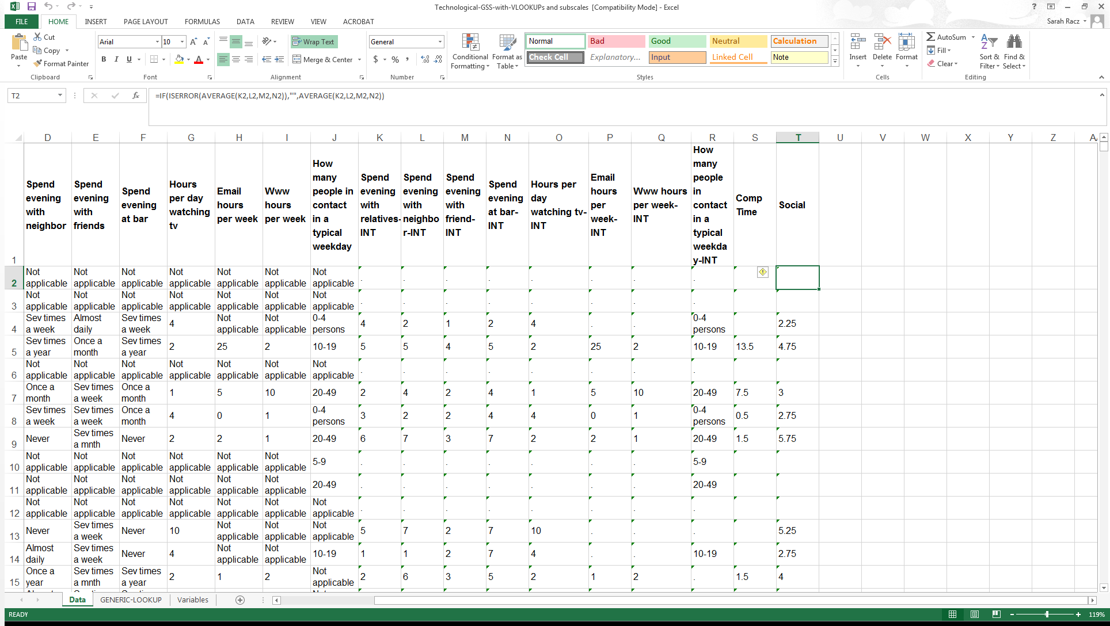

1. Provide the mean, median, mode, sample standard deviation, and sample variance for the “Democracy,” “Comp Time,” and “Social” subscale variables **(15 points)**
   * Round all statistics to two decimal places.

|  |  |  |  |
| --- | --- | --- | --- |
|  | **Democracy** | **Comp Time** | **Social** |
| **Mean** | 5.68383 | 8.69612 | 4.41019 |
| **Median** | 5.75 | 5 | 4.25 |
| **Mode** | 7 | 0 | 4 |
| **Sample Standard Deviation** | 0.98451 | 11.04907 | 1.07423 |
| **Sample Variance** | 0.96927 | 122.08208 | 1.15397 |

**Submission and Grading**

This is an individual assignment. You must submit the following three files to ELMS for this assignment:

1. The .XLS file for the Political Project, with the encoded data and completed total mean score “Democracy” column.
2. The .XLS file for the Technology Project, with the encoded data and completed total mean score “Comp Time” and “Social” columns.
3. This document, as a Word file, with the completed tables.

**ASN6 will be scored out of 32 points, and is worth 2.5% of your grade.**